20IT4303: ADVANCED DATA STRUCTURES & ALGORITHMS
HOME ASSIGNMENT-2 QUESTIONS
A.Y:2021-22
S.NO | QUESTION | COURSE OUTCOME | BTL
5 | Design an algorithm for Strassen’s matrix multiplication using divide and conquer strategy and estimate the time complexity of the designed algorithm in best, average and worst cases. Trace the algorithm with an example. | CO2 | Apply
6 | 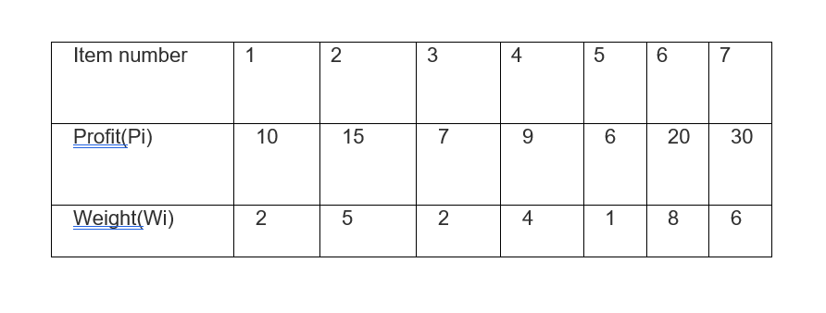  Solve the problem as Knapsack problem to find the optimal solution | CO2 | Apply
15 | 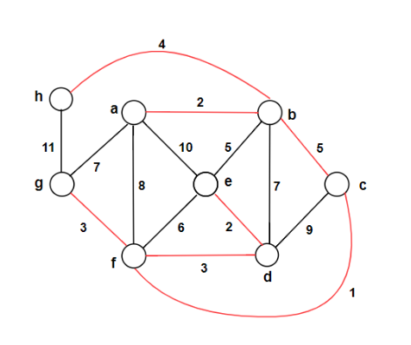  Find the minimum cost spanning tree using prims and kruskals algorithms | CO2 | Apply
20 | 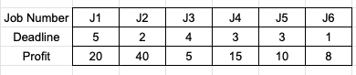  Solve the problem of job sequencing with deadlines to find the optimal solution | CO2 | Apply
25 | 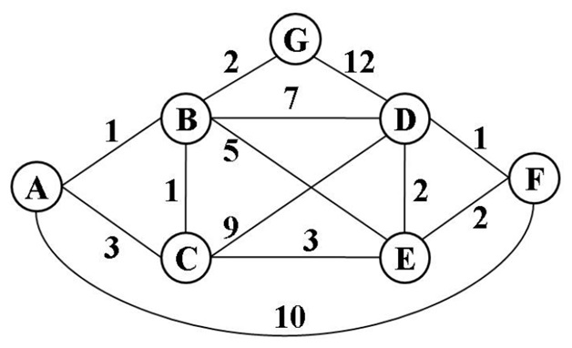  Find the shortest path from source ‘A’ to all other vertices | CO2 | Apply

Regd.No | Question Number | Regd.No | Question Number | Regd.No | Question Number
 |  | 208W1A1299 | 5,6,15,20,25

